**HEALTH TRACKER**



**END TERM REPORT**

***By :***

**Names of Candidates:**

**Ritik Raj**

**Nishant Mehta**

**Manoj Sharma**

Section: K19QK

Roll Numbers: 19, 10, 70

**Department of Intelligent Systems,**

**School of Computer Science Engineering,**

**Lovely Professional University, Jalandhar**

November, 2020

**ACKNOWLEDGEMENT**

In preparation of our assignment, we took the help and guidance of some respected persons, who deserved our greatest gratitude. As the completion of this assignment of this assignment gave us much pleasure, we would like to show our gratitude Mr. Dhanpratap Singh, Course Instructor, on LOVELY PROFESSIONAL UNIVERSITY for giving us a good guideline for assignment throughout numerous consultations. In addition, a thank you to Professor Dhanpratap Singh, who introduced me to the Methodology of work and whose passion for the underlying structures had lasting effects.

**Student Declaration**

This is to declare that this report has been written by us. No part of the report is copied from other sources. All information included from other sources have been duly acknowledged. We aver that if any part of the report is found to be copied, we are shall take full responsibility for it.

Name: Ritik Raj

Nishant Mehta

Manoj Sharma

Roll Number:19,10,70

**TABLE OF CONTENTS**

**TITLE: HEALTH TRACKER**

|  |  |
| --- | --- |
| * **Background and objectives of project HEALTH TRACKER** |  |
| **What Is Health Tracking?** |  |
| * **What You Need to Know About Health Tracking?** |  |
| **How Might Health Tracking Data Be Used?** |  |
| **What Are the Risks?** |  |
| **Where Is Health Tracking Headed?** |  |
| * **Objective of health tracking** |  |
| * **Keep track of your progress** |  |
| * **Free workout trainer and tips** |  |
| * **Helps in setting achievable goals** |  |
| * **Monitoring your health** * **User friendly fitness tracker interface** * **It's All in Good Measure** * **DESCRIPTION** * **HEALTH TRACKER** * **PICTORIAL VIEW** * **WORK DIVISION AMONG GROUP MEMBERS** * **TECHNOLOGIES AND FRAME WORK USED** * **SWOT ANALYSIS** * **PROJECT LINK** |  |

## **Background of health tracking**

## **What Is Health Tracking?**

The term health tracking refers to the collection and analysis of various data points related to one’s health. Popular devices like Misfit Shine can track steps, calories, altitude, and sleep patterns. Others, like [Fitbit Surge](https://www.fitbit.com/surge" \t "_blank), incorporate functionality like heart rate monitoring and GPS tracking to record the route you took on a run or bike ride. The newly introduced Apple Watch tracks how long you’ve been sedentary and reminds you to get up and stretch or take a short walk. Health tracking technology is changing fast, as companies compete for consumers by offering an ever-growing array of features and capabilities.

**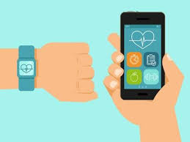**

**What You Need to Know About Health Tracking?**

From wristbands and watches to phones, apps, earbuds, and more, we are in the midst of a health tracking boom. A recent report projects that the [global health tracking market](http://www.bccresearch.com/pressroom/hlc/mobile-devices-driving-unprecedented-growth-in-self-monitoring-technologies-markets) will grow from its 2013 value of $1.1 billion to $18.8 billion in 2019. Building on the step-counting capabilities of pedometers, health tracking devices have evolved to record all kinds of health-related activities. But what use are we making of all this data? Are there downsides we haven’t considered? And what is in store for the future of health tracking technology?

## **How Might Health Tracking Data Be Used?**

The potential value of health tracking extends beyond the consumer fitness market. Companies have long offered incentives (and sometimes penalties) to [encourage their employees to cultivate healthy fitness habits](http://www.theguardian.com/lifeandstyle/us-money-blog/2015/may/01/employers-tracking-health-fitbit-apple-watch-big-brother) as a means of keeping productivity high and overhead low. Health tracking may give employers another way to motivate healthy habits, as well as providing insight into things like stress and energy levels, which could lead to improved management and policy development.

Health care providers could incorporate the data from health tracking devices into electronic health records and other [health informatics systems](http://healthinformatics.uic.edu/). Patient data could be used to improve individual treatment plans, as well as aggregated for research purposes.

## **What Are the Risks?**

There are concerns about the [security of health tracking devices](http://www.forbes.com/sites/larrymagid/2014/07/31/safety-security-and-privacy-risks-of-fitness-tracking-and-quantified-self/). If your device gets hacked, a great deal of information could be exposed, from your age, gender, weight, and height, to your home address and exercise routes and habits. Experts recommend educating yourself about how data is transmitted and protected before choosing a device. (A strong password won’t protect you if the manufacturer hasn’t taken the necessary steps to encrypt passwords during transmission.) For extra peace of mind, take the added precaution of turning off the device’s wireless functionality when you’re not using it.

## **Where Is Health Tracking Headed?**

Some insiders believe the next phase of health tracking technology will make today’s most advanced devices obsolete. Imagine wearing an electronic skin patch, as thin and flexible as a temporary tattoo, that monitors your vital signs and tracks indicators related to chronic illnesses like diabetes or a heart condition. Researchers at Seoul University have developed a prototype patch that can not only dispense medication but is smart enough to do so only when necessary, like when an epileptic patient experiences a seizure.

**Objective of health tracking**

Many Indians, these days, use wearable devices to keep up with their health and fitness. A fitness tracker is a device that uses sensors to track your orientation, movement, and rotation. The device collects data and converts it into steps, calories, sleep quality and general activity you perform through the day. Some trackers even have a sensor called 'altimeter' which measures your altitude, thereby tracking the number of flights of stairs you've climbed. A fitness tracker can easily figure whether you are running or spinning.  The alarm in the tracker reminds you about a range of things such as- completing the number of steps, drinking enough water, standing, walking, sleeping on the right time and much more.

The device offers solutions to individuals interested in working toward specific health and fitness goals. Here are a few uses and benefits of using a fitness tracker

**Keep track of your progress**

With a fitness tracker on, you want to keep up with the goals it projects. This is because regular reminder boosts your motivation levels. A fitness tracker lets you record your exercise statistics. It generates detailed info-graphics and reports so that you can look how far you have come.

**Free workout trainer and tips**

It is difficult to plan a solid fitness routine and adhere to it religiously when you are a busy person. Luckily, a fitness tracker offers different workout ideas that are customized to cater to your current fitness level.

**Helps in setting achievable goals**

To achieve the best results, you will have to set a realistic goal that can be achieved. You cannot shed weight if you lead a sedentary life and do not exercise. However, if you use a fitness tracker, it will help you set and achieve realistic goals within the recommended time frame. It also makes sure that you do not get de-motivated and quit midway.

**Monitoring your health**

Indulge in self-care and track your fitness level. A fitness tracker lets you watch and record your heart rate, daily burned calories and step counts. Self-tracking allows you to stick to a healthier diet, exercise more and sleep better.

**User friendly fitness tracker interface**

Regular use of fitness tracker boosts your daily workouts and makes them achievable. Most trackers have built in screens, statistics, vibrating alarms, and history tracking. These features make it easy for users to check their progress instantly without interrupting their workout sessions.

**Helps you to stay motivated**

Working out and maintain a fit body includes both good and bad weeks. You ought to experience them as sleep and activity patterns vary across the days, weeks, and months. A fitness tracker enables you to determine such habits that are effortlessly maintainable so that you can achieve your long termexercise goals. Furthermore, most tracking devices let you share your progress with your friends on social media and create personal workout groups with competitive goals.

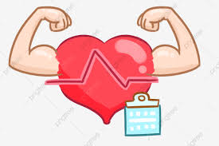

**It's All in Good Measure**

Why this sudden need for recording your fitness activities? Research proves that by keeping track of your day to day activities, you can significantly improve our health. Self-tracking can make you sleep better, follow a healthier diet, and exercise more- just by letting you know the areas you need to improve. All in real time!

Personal fitness trackers ensure that you can focus on enjoying better health and getting in shape through tracking your daily activities. However, a disease comes without knocking, and you should keep yourself ready to fight with it. It is advisable to protect yourself against ever-increasing medical rates by buying a health insurance policy. You can get a health insurance policy without any paperwork online.

**DESCRIPTION**

HEALTH TRACKER:

A health tracker is an electronic application used to record and manages healthy living statistics and measure progress, but what does it really mean? A health tracker is a way to take all your data and put it together to form a meaningful picture of your overall lifestyle, be it healthy or not so.

we made this project (Health Tracker) with use of Python programming language.

This project is GUI based program, where we used tkinter module, functions and other parts.

For tracking your health with full accuracy we need sensor. But here in our project, it is software based where we are not using any hardware. Although the software we created takes the inputs from user.

As we are not using any hardware

1. So first user will give the input like Enter steps, then program will calculate calories according to the steps.

2. Same as first user will now enter how many pushups he did, after that program will show you the calories you burnt, also it calculates the heart points according to the age.

**Used Formulas:**

Calories burn from walk = total number of steps x 0.045

Maximum heart points according to age=205.8-(0.685x (Age))

Calories burnt from pushups = total number of pushups x 0.34

Calories burnt from squats = total number of squats x 0.32

**PICTORIAL VIEW**

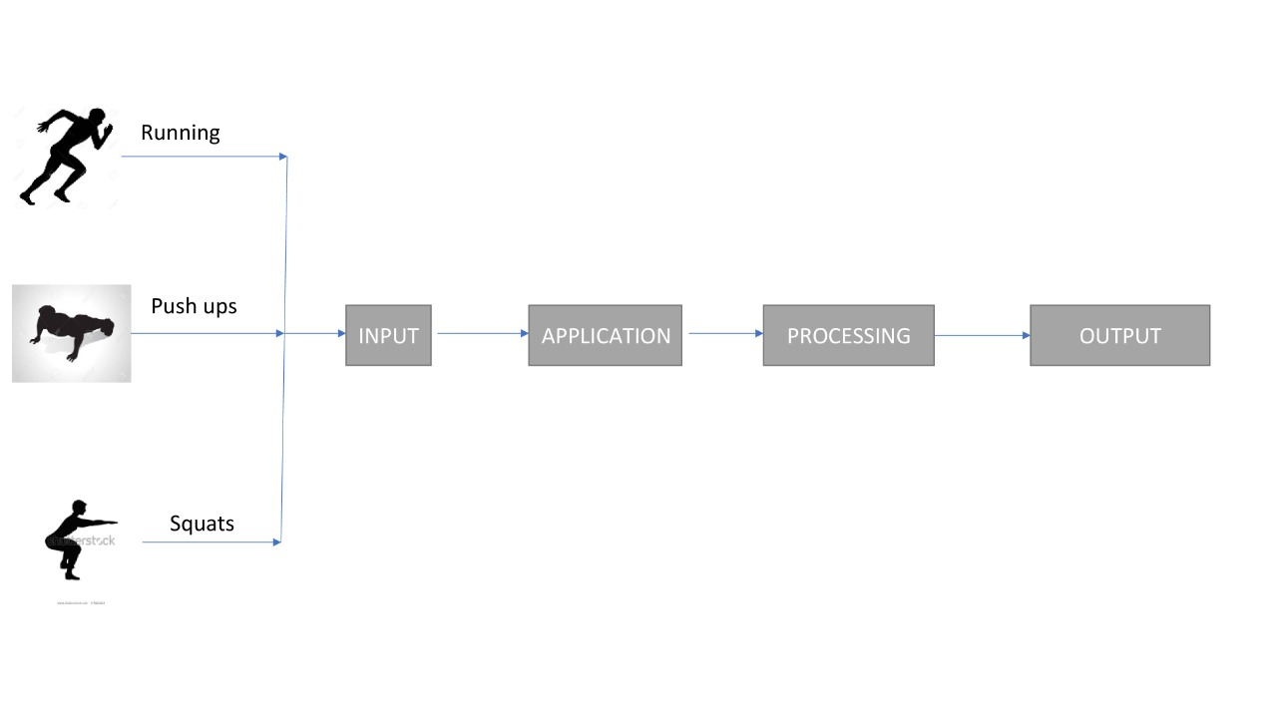

**WORK DIVISION AMONG GROUP MEMBERS**

**Work done by Ritik Raj:**

Most of the programming part of the project is done by Ritik Raj. Used Python programming for the project, including Tkinter for GUI based project.

**Work done by Manoj Sharma:**

Report writing part is been done by Manoj Sharma. Using MS-WORD for the project.

**Work done by Nishant Mehta:**

Designing part and Pictures used is been done by Nishant Mehta. He also co-ordinate the team.

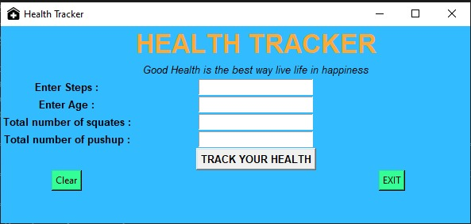

**TECHNOLOGIES AND FRAME WORK USED**

**Programming Language :**

Python Programming: Python is an interpreted, high-level and general-purpose programming language. Created by Guido van Rossum and first released in 1991, Python's design philosophy emphasizes code readability with its notable use of significant whitespace. Its language constructs and object-oriented approach aim to help programmers write clear, logical code for small and large-scale projects

**IDE Used:**

Visual Studio Code: Visual Studio Code is a free source-code editor made by Microsoft for Windows, Linux and macOS. Features include support for debugging, syntax highlighting, intelligent code completion, snippets, code refactoring, and embedded Git. Users can change the theme, keyboard shortcuts, preferences, and install extensions that add additional functionality.

**For GUI :**

Tkinter: Tkinter is a Python binding to the Tk GUI toolkit. It is the standard Python interface to the Tk GUI toolkit, and is Python's de facto standard GUI.Tkinter is included with standard Linux, Microsoft Windows and Mac OS X installs of Python.

**SWOT ANALYSIS**

**Strength :** This project can help us to be more fit and healthy by calculating the amount of calories according to our steps and other workouts like , Pushups, Squats , etc. Also it can calculate users maximum heart points which is used by Google fit , according to there age .

**Weakness:** Tracking your health will be more accurate with the sensors but our project is not hardware based. So this will work only according to the user. In this project we didn’t use any security based things.

**Opportunities:** In today’s time, everyone is not considering on there physical fitness/ health, due to which people are getting sick day by day. With the help of these app , we can help them to manage there physical fitness/health . Health/physical fitness industry is growing day by day, by introducing this app we can also provide job opportunities to other people.

**Threats:** People/Hackers can misuse this app to track the day to day routine of a person and can cause him trouble in life by tracking their location and can break into their house and steal/rob their house. It will be an ideal app if someone wants to kidnap a person as they already know the location of that person and they don’t have to find that person.

**BIBLIOGRAPHY**

* **Websites:**

[www.tutorialspoint.com](http://www.tutorialspoint.com)

[www.geeksforgeeks.com](http://www.geeksforgeeks.com)

<https://docs.python.org/>

* **Personal help from our Sir (Dr. Dhanpratab Singh)**

**PROJECT LINK**

* <https://github.com/Ritik8141/INT213>

***STAY FIT***

